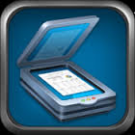

**Tiny Scan Pro--PDF**

Use: Scanning documents into ipad

1. Open Tiny Scan Pro app.
2. Select camera icon in upper right corner.
3. Take picture of the paper you want to import.
4. Move the corners so they will crop the image to the correct dimensions (remove excess around page)
5. Click Next
6. Choose color, grayscale, or Black & White (on bottom, under photo). You can also adjust the brightness and contrast with the sun button. Select Save.
7. To Open in another app, select the box with arrow, and choose Open in. Select the desired app.