

**Making Sequences**

Use: Sequencing Assignments

To create a new sequence:

1. Using iPad camera, take a picture of the paper that needs to be sequenced (as many times as there are sequencing items….if there are 4 items to sequence, take a picture 4 times). **
2. Go to Camera Roll (bottom left corner) and select that picture.
3. Touch anywhere on the screen to get a toolbar on top.
4. Click Edit (top toolbar)
5. Select Crop (bottom toolbar).
6. Move corners so only one of the photos is showing.
7. Select Crop (upper right corner)
8. Select Save
9. Continue to do so for the remaining images until you only have the individual pictures.

** Alternatively, you can cut the pictures apart, and then take individual photos of them.**

1. Open Making Sequences App.

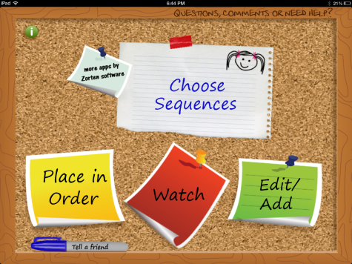

1. Select Edit/Add
2. Select Add a new sequence
3. Select Add an image and audio
4. Click Choose from Library.

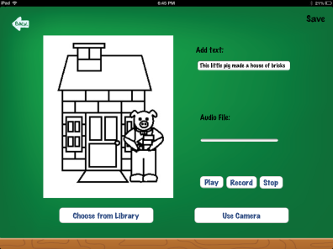

1. Select the picture you want.
2. Type text in the “Add Text” box at the top
3. You may choose to record a sentence as well (e.g., The piggy made his house out of sticks.)
4. Save (top right corner)
5. Continue selecting “Add an image and audio” until you have all of the pictures in the sequence.
6. Type in a sequence name in the top white text box (e.g., The 3 Little Pigs)
7. Select Save
8. Be sure your images are in the correct order. If they aren’t, select “Re-Order/Delete” (top right corner). Grab the white lines to move the image to a new location.
9. Save.

To DO the sequence activity:

1. Open Making Sequences app.
2. Select Choose Sequences
3. Select the sequence activity you wish to complete (a green check mark will be placed next to the selected sequence).

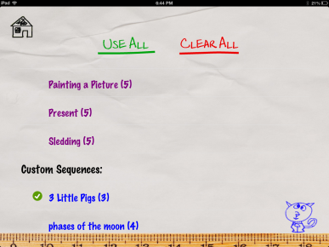

1. Press the home button (upper left corner)
2. Select Place in Order

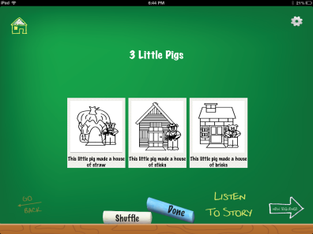

1. Drag and drop to put items in order.
2. Select Done to see if you are correct.
3. To save the sequence, take a screen shot by holding down the power and nuvi button. The image will be in your camera roll. It can be emailed from there.