**Inspiration 9.0**

**Diagram View**

Use Diagram View to create diagrams that show the relationships between ideas or concepts. Here’s what Diagram View looks like:

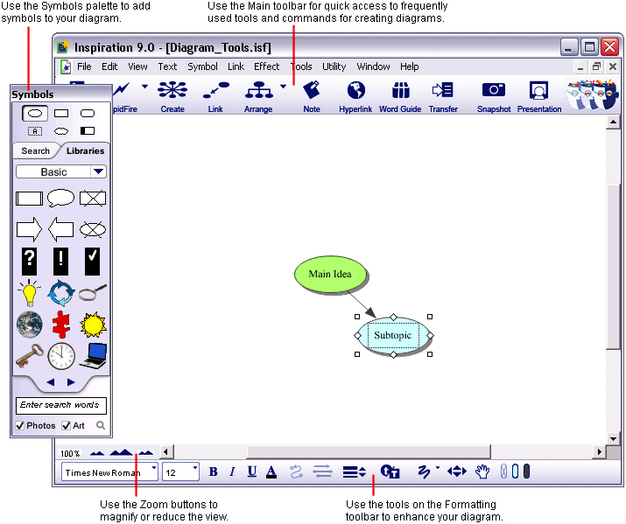

**Enter a main idea**

The Main Idea symbol provides a starting point for your work. It’s easy to get started—just type!

**Add ideas quickly using the RapidFire® tool**

The RapidFire tool allows you to add a series of ideas that are connected to a symbol. Select the main idea symbol button if it’s not already selected. On the Main toolbar, click the RapidFire button. A red lightning bolt appears in the symbol to show that the RapidFire tool is turned on. Type a related ideaand press Enter. You can keep typing ideas, pressing Enter after each.

Click the RapidFire button again to turn the RapidFire tool off. You’ll notice there’s now a Subtopic Quick Control near the upper right

**Use the Create tool to add a linked symbol**

To add a linked symbol in any direction, use the Create tool.

Select a bubble you want to add an idea to. On the Main toolbar, position the mouse pointer over the point on the **Create** button that shows the direction you want a bubble to be created. When you move the mouse over a point on the **Create** button, it highlights to show the direction in which the new symbol will be created.

**Search for a symbol**

When you search for symbols, Inspiration searches both the Inspiration libraries on your computer and the online collection.

*Note:* The Online Access option is selected by default. To turn Online Access off, choose **Preferences** in the **Utility** menu, then make sure the **Online Access** box is not checked.

Select a bubble you want to add a symbol to. In the box at the bottom of the Symbols palette, type the word you are looking to search for. Click the **Find** button. Inspiration searches for all images containing your keywords. Click one of the images that appear. Since it was selected, the symbol automatically changes to your selection.

**Connect ideas using the Link tool**

Links show the relationships and connections between ideas. When you use the RapidFire With Links tool or the Create tool, your ideas are automatically linked. You can also create links.

Select a bubble. This is the symbol where the link will start. On the Main toolbar, click the **Link** button to turn on the Link tool. Click the symbol where the link will end.

A link with the arrowhead pointing to thatsymbol appears. Click the first bubbleagain.

Now click a different bubble. A second link appears and the arrowhead points to the *new* symbol. Continue to link symbols together. Click on the first symbol and then the symbol where you want the link to end. Click the **Link** button again to turn off the Link tool.

**Label the connections between ideas**

Each link has a text box that appears when the link is selected. Adding text to this box defines the relationship between the symbols.

Select the link between two concepts. When a link is selected, you see the outline of the text box associated with that link. It’s ready for you to enter text.

Right-click on the link text box. Choose **includes** from the **Linking Phrases** shortcut menu.

C:\Users\BethandJim\AppData\Local\Microsoft\Windows\Temporary Internet Files\Content.IE5\UBOLBW1T\MC900435446[1].wmf

includes

**Add a note to a symbol**

A note is available for each symbol in a diagram. Notes allow you to expand ideas and actually begin the writing process while continuing to work in a visual format.

Select a symbol. On the Main toolbar, click the **Note** button. A note opens below the symbol.

**Arrange a diagram using the Arrange tool**

The Arrange tool changes a freeform diagram into a more structured layout. You can apply one of three basic arrangements to a diagram, then make refinements using the Arrange options.

Select **the main idea.** On the Main toolbar, click the **Arrange** button. Select the desired layout. Click **OK**. The diagram automatically rearranges into the new format.

**Outline View**

Use Outline View to create outlines of your ideas or to organize and write reports.

Here’s what Outline View looks like:

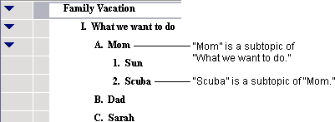

**Switch from Diagram View to Outline View**

When you switch to Outline View, your information is instantly displayed in a traditional hierarchy.

Select **your main idea**. Click the **Outline** button on the Main toolbar. The diagram is transformed into an outline. The symbols now appear as topics and subtopics. In addition, link text you added to your map or diagram is displayed in the outline.

*Tip:* You can show or hide link text using the **Show Link Text** button on the Formatting toolbar. You can also show or hide diagram or mind map symbols with the **Show Symbols** button .

**Add a topic**

Topics are the core ideas in your outline. You can add a new topic in Outline View as easily as you added a new symbol in Diagram View.

Selecta topic by clicking in the Selection Control column. A colored box appears around the topic to show it’s selected. On the Main toolbar, click the **Topic** button.

Inspiration inserts a new topic and automatically assigns it a prefix. The cursor moves to the new line so you’re ready to enter text for your new idea.

**Add a subtopic**

In the same way you added a new topic, you can add new subtopics. These ideas provide information that is subordinate or supplemental to a topic.

Click the **Subtopic** button on the Main toolbar. When you add a subtopic, Inspiration automatically indents it one level below the selected topic and assigns it a prefix. The cursor also moves to the new line so you can enter text for the new idea.

**Move a topic by dragging**

There are many ways to organize your outline. The most direct is simply dragging a topic up or down in the outline. Any subtopics associated will move with it. While you drag, the topic remains in its original position until you release the mouse button. You can tell where the topic’s new location will be by watching the gray line as you drag. The small highlighted dot indicates the indentation level of the topic’s new location.

**Change the level of a topic**

To move a topic to a lower or higher level in the outline, use the Right or Left tool to move it up and down in the hierarchy.

**Split a topic**

Sometimes you might want to split a topic into two. Position the text cursor between the two words you want to split in the outline. Click the **Split** button on the Main toolbar.

**Transfer your document to a word processor**

When you are ready to finalize your work for publication, you can easily transfer it to a word processor. The Transfer tool automatically launches Microsoft Word, or OpenOffice.org Writer.

Click the **Transfer** button on the Main toolbar. The first time you use the Transfer tool, Inspiration will prompt you to choose your word processor. You can change this later in Inspiration’s Preferences, available from the **Utility** menu. The Transfer Options dialog appears. Select your preferred options and click **OK**.

Inspiration automatically launches your preferred word processor and transfers your work.

**Templates**

Inspiration comes with templates for language arts, science, social studies, and thinking and planning. From the main menu, you can select templates, or go to **File, Open Template** to select a template.