**iAnnotate PDF**

Use: drawing, writing, typing on worksheets

M

1. Open TinyScan
2. Scan desired document or select it if already scanned
3. Select the box with arrow at top toolbar, and choose Open in
4. Select iAnnotate PDF app
5. The document will automatically open in iAnnotate PDF

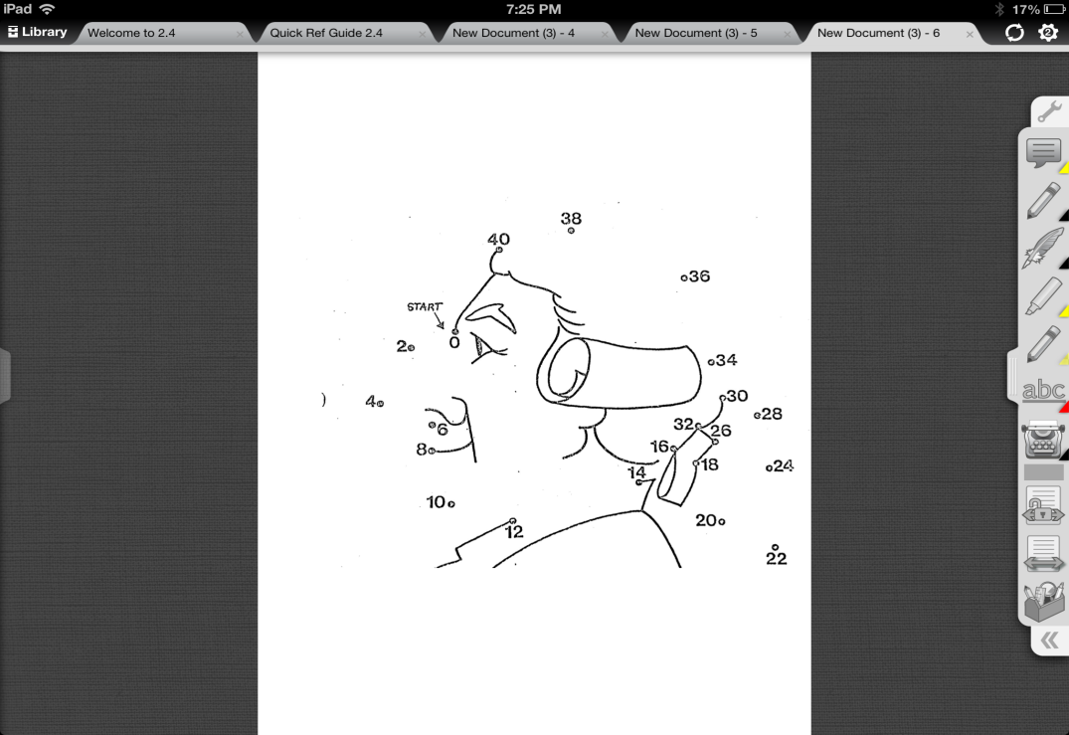

1. To draw with a pencil, select the pencil tool.
2. A pencil toolbar will appear which will give you color options as well as the ability to erase. (To completely clear a page after you have already hit Done, double click on the writing, and select Delete).
3. To type in a response, select the typewriter tool.
4. Tap on the page, to create a text box. The keyboard will automatically appear. After you are finished typing your response, press the keyboard button (bottom right) to make it disappear. This will make the text flash. You can move it anywhere you like on the paper now. You can also adjust the font size or look with the font toolbar document tab. r. When you are satisfied with the look and location of the text, select Done from the type toolbar.
5. When the document is complete, it can be emailed by going to the toolbox icon (bottom of the toolbar) and selecting the Document tab.
6. Select Email Document
7. Then Select Flattened