[](http://www.google.com/url?sa=i&rct=j&q=doodle+buddy&source=images&cd=&cad=rja&docid=LmVj_5ZJka1LfM&tbnid=Qpg1r_-RP822aM:&ved=0CAUQjRw&url=https://itunes.apple.com/us/app/doodle-buddy-paint-draw-scribble/id313232441?mt=8&ei=K82kUZPAM5TV0gHDpoCgCQ&bvm=bv.47008514,d.dmQ&psig=AFQjCNFW-9wTKBhBatfvF0-aUQcvrqgNVw&ust=1369841264065119)

**Doodle Buddy**

1. Using ipad camera, take a picture of the paper that needs to be completed.
2. Open Doodle Buddy App
3. Select the paper you want to color by touching the tic-tac-toe board on the bottom tool bar

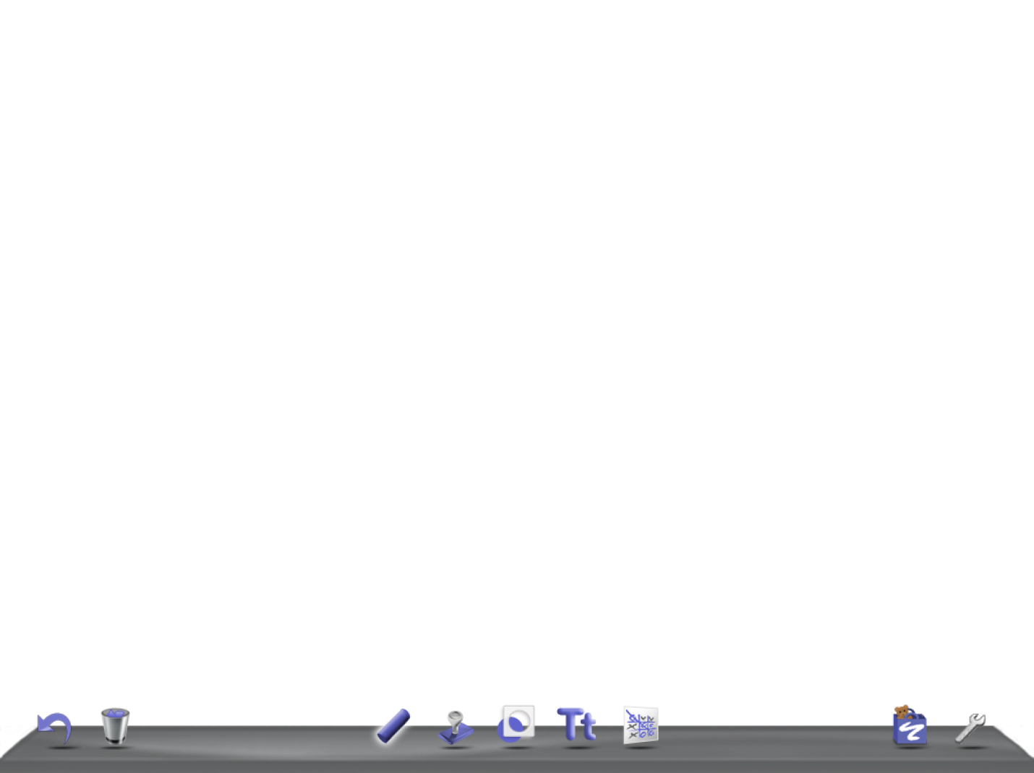

1. Select Photos, and choose the photo from your camera roll.

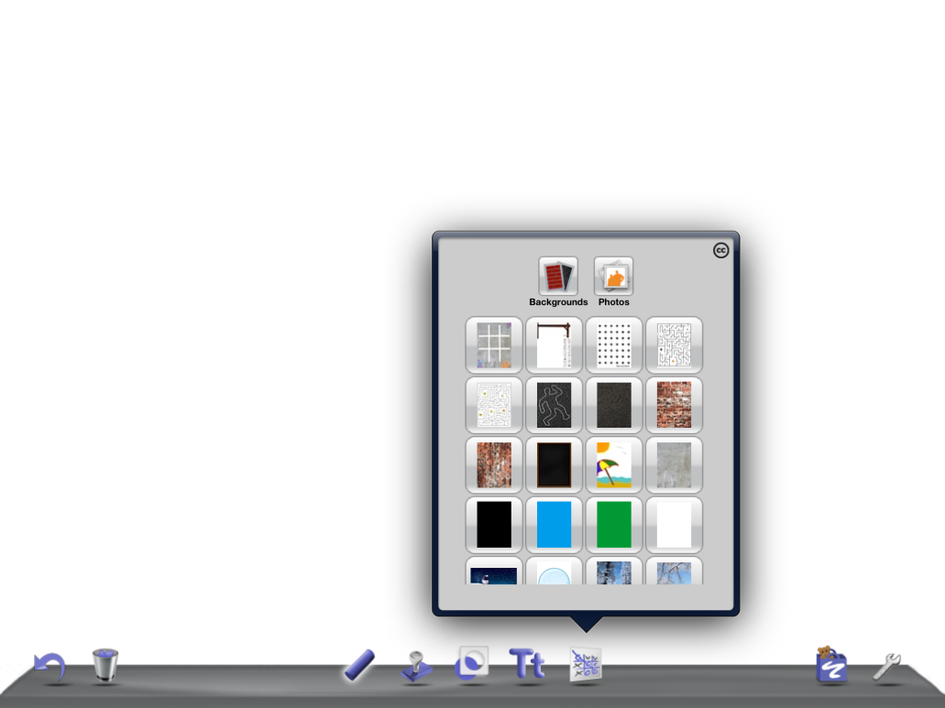

1. To color, select the chalk icon
2. Select the medium…paint brush, chalk, glitter, smudge, or eraser from the top row

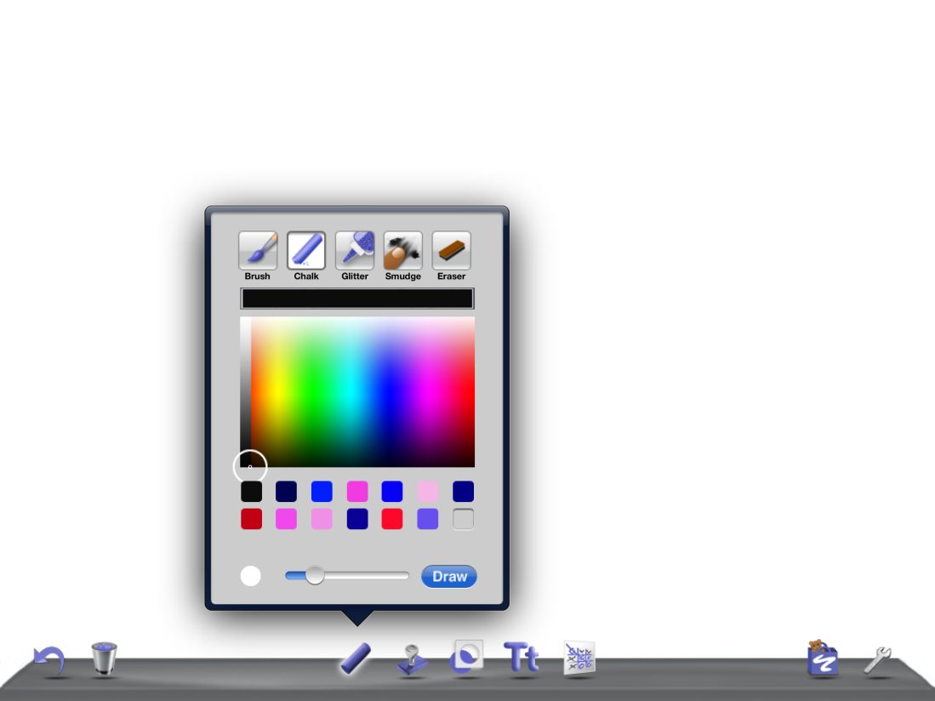

1. Select the color
2. Adjust the size of the “brush” with the slider along the bottom.
3. To add text, select the “Tt” on the bottom toolbar.



1. There are 4 font types available (top row). When you touch in the rectangular box, the keyboard will appear. You can resize the box (which will automatically resize the font) by holding the dotted right lower corner (red arrow) and sliding larger or smaller. The gray bar on the bottom (blue arrow) will allow you to move the box to another area on the paper.

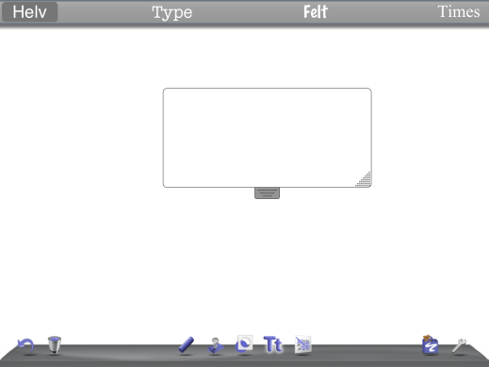

1. When you are all done, you can select the wrench (lower right corner of toolbar). You may send in an email or save to photo album. 