[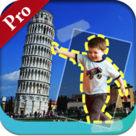](https://www.google.com/url?sa=i&rct=j&q=&esrc=s&frm=1&source=images&cd=&cad=rja&docid=xS_WLcjEBAPexM&tbnid=7p60l27HRUtwhM:&ved=0CAUQjRw&url=https://itunes.apple.com/us/app/cut-me-out-pro/id597526128?mt=8&ei=d1LcUYnZDpP64AOuy4DgBQ&bvm=bv.48705608,d.dmg&psig=AFQjCNG8bwHDLW9NLFI-BD2iI1cJsem6zw&ust=1373479877558397)**Cut Me Out Pro**

Use: cut and paste worksheets

1. 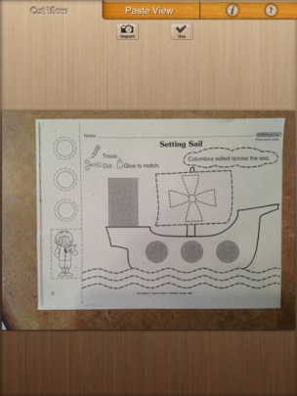Open Cut Me Out Pro

2. Click on Cut View tab

1. Select Import
2. Select Photo Album (if worksheet has already been scanned)
3. Choose Photo
4. Cut the photo by drawing a line around the image you want to cut out.
5. Select Use if you approve of the shape or redraw
6. Continue to cut out all of the shapes by returning to the Cut View tab.
7. Once all images have been cut, move them around on the desktop of the Paste View so they can all be seen.

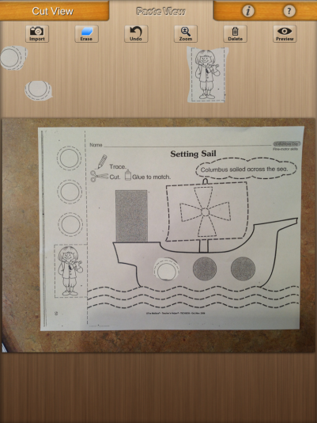

1. Select the background image on Paste View, by selecting Import. Select the image you wish to have for your background.
2. Move the cut out images onto the background picture.
3. Select Preview when you are done. It can be saved to the camera roll or emailed. If you save to camera roll, the image can be opened in Doodle Buddy for coloring or writing if necessary.